aggregate()

aggregate method of model manager is used to apply aggregate function on model/table

- Avg
- Max
- Min
- Count
- Sum

Syntax: model-name.objects.aggregate(aggregate-function)

>>> from app1.models import Student
>>> from django.db.models import Sum,Min,Max,Count
>>> Student.objects.aggregate(Sum('fee'))
{'fee__sum': 8500.0}
>>> res=Student.objects.aggregate(total_fee=Sum('fee'))
>>> type(res)
<class 'dict'>
>>> print(res)
{'total_fee': 8500.0}
>>> print(res['total_fee'])
8500.0
>>>
>>> d1=Student.objects.aggregate(Sum('fee'),Max('fee'),Min('fee'))
>>> print(d1)
{'fee__sum': 8500.0, 'fee__max': 3000.0, 'fee__min': 1000.0}
>>> print(d1['fee__sum'])
8500.0
>>> print(d1['fee__max'])
3000.0
>>> d2=Student.objects.aggregate(a=Sum('fee'),b=Max('fee'),c=Min('fee'))
>>> print(d2)
{'a': 8500.0, 'b': 3000.0, 'c': 1000.0}
>>> print(d2['a'],d2['b'],d2['c'])
8500.0 3000.0 1000.0
>>>
>>> qs=Student.objects.filter(course='c++')
>>> print(qs)
<QuerySet [<Student: 3,kishore,c++,1000.0>, <Student: 4,ramesh,c++,1500.0>]>
>>> d1=qs.aggregate(Sum('fee'))
>>> print(d1)
{'fee__sum': 2500.0}
>>> d2=qs.aggregate(Count('fee'))
>>> print(d2)
{'fee__count': 2}
>>>

annotate():
Adds a calculated "extra" field to each object in a QuerySet.
Return Type: Returns a QuerySet, allowing you to chain further methods like .filter() or .order_by().
Analogy: Like adding a temporary new column to every row in a table.
Use Case: Getting each author with their total number of books

>>> qs=Student.objects.annotate(total=Sum('fee'))
>>> print(qs)
<QuerySet [<Student: 1,naresh,python,3000.0>, <Student: 2,suresh,java,2000.0>, <Student: 3,kishore,c++,1000.0>, <Student: 4,ramesh,c++,1500.0>, <Student: 5,kiran,c,1000.0>]>
>>> for stud in qs:
... print(type(stud))
...
<class 'app1.models.Student'>
<class 'app1.models.Student'>
<class 'app1.models.Student'>
<class 'app1.models.Student'>
<class 'app1.models.Student'>
>>> for stud in qs:
... print(stud.rollno,stud.name,stud.course,stud.fee,stud.total)
...
1 naresh python 3000.0 3000.0
2 suresh java 2000.0 2000.0
3 kishore c++ 1000.0 1000.0
4 ramesh c++ 1500.0 1500.0
5 kiran c 1000.0 1000.0
>>> qs=Student.objects.values('course').annotate(total=Sum('fee'))
>>> print(type(qs))
<class 'django.db.models.query.QuerySet'>
>>> print(qs)
<QuerySet [{'course': 'python', 'total': 3000.0}, {'course': 'java', 'total': 2000.0}, {'course': 'c++', 'total': 2500.0}, {'course': 'c', 'total': 1000.0}]>
>>> qs=Student.objects.values('course').annotate(c=Count('rollno'))
>>> print(qs)
<QuerySet [{'course': 'python', 'c': 1}, {'course': 'java', 'c': 1}, {'course': 'c++', 'c': 2}, {'course': 'c', 'c': 1}]>
>>>

Create project
Create application within project

Settings.py
INSTALLED_APPS = [
'django.contrib.admin',
'django.contrib.auth',
'django.contrib.contenttypes',
'django.contrib.sessions',
'django.contrib.messages',
'django.contrib.staticfiles',
'app2'
]
TEMPLATES = [
{
'BACKEND': 'django.template.backends.django.DjangoTemplates',
'DIRS': [BASE_DIR/"templates"],
'APP_DIRS': True,
DATABASES = {
'default': {
'ENGINE': 'django.db.backends.sqlite3',
'NAME': 'database10',
'USER':'root',
'PASSWORD':'root',
'HOST':'localhost',
'PORT':3306
}
}

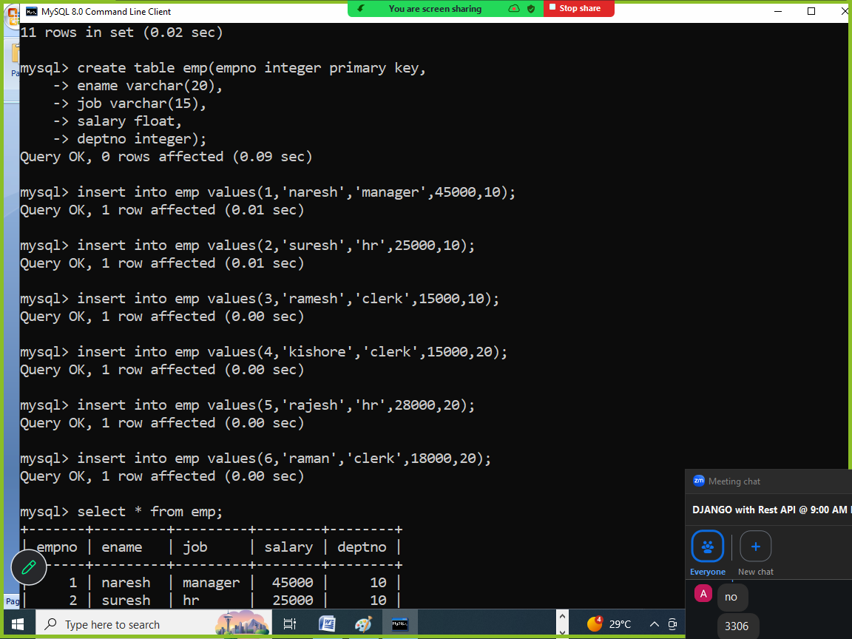

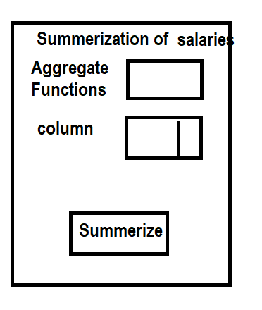

Views.py
from django.shortcuts import render
from app2.models import Employee
from django.db.models import Avg,Max,Min,Sum,Count
# Create your views here.

def empview(request):
f=request.GET.get('agg')
c=request.GET.get('cname')
if f=="max":
qs=Employee.objects.values(c).annotate(a=Max('salary'))

elif f=='min':
qs=Employee.objects.values(c).annotate(a=Min('salary'))
elif f=='sum':
qs=Employee.objects.values(c).annotate(a=Sum('salary'))
elif f=='count':
qs=Employee.objects.values(c).annotate(a=Count('salary'))
elif f=='avg':
qs=Employee.objects.values(c).annotate(a=Avg('salary'))
print(qs)
response=render(request,"emp_temp.html",context={'qs':qs,'cname':c})
return response

def emphome(request):
response=render(request,"emp_temp.html")
return response

urls.py
"""
URL configuration for project11 project.

The `urlpatterns` list routes URLs to views. For more information please see:
https://docs.djangoproject.com/en/6.0/topics/http/urls/
Examples:
Function views
1. Add an import: from my_app import views
2. Add a URL to urlpatterns: path('', views.home, name='home')
Class-based views
1. Add an import: from other_app.views import Home
2. Add a URL to urlpatterns: path('', Home.as_view(), name='home')
Including another URLconf
1. Import the include() function: from django.urls import include, path
2. Add a URL to urlpatterns: path('blog/', include('blog.urls'))
"""
from django.contrib import admin
from django.urls import path
from app2.views import emphome,empview
urlpatterns = [
path('admin/', admin.site.urls),
path("",emphome),
path("emp/",empview),
]

Emp_temp.html
<!DOCTYPE html>
<html lang="en">
<head>
<meta charset="UTF-8">
<meta name="viewport" content="width=device-width, initial-scale=1.0">
<title>Document</title>
</head>
<body>
<form action="/emp" method="GET">
<table border="2" width="100%">
<tr>
<td>Aggreate Function</td>
<td><select name="agg">
<option value="sum">Sum</option>
<option value="count">Count</option>
<option value="max">Max</option>
<option value="min">Min</option>
<option value="avg">Avg</option>
</select></td>
</tr>
<tr>
<td>ColumnName</td>
<td><select name="cname">
<option value="deptno">Deptno</option>
<option value="job">Job</option>
</select></td>
</tr>
<tr>
<td><input type="submit" value="display"></td>
<td><input type="reset" value="clear"></td>
</tr>
</table>
</form>
<table border="2" width="100%">
{%for row in qs%}
<tr>
{%if cname == 'deptno'%}
<td>{{row.deptno}}</td>
<td>{{row.a}}</td>
{%endif%}
{%if cname == 'job'%}
<td>{{row.job}}</td>
<td>{{row.a}}</td>
{%endif%}
</tr>
{%endfor%}
</table>
</body>
</html>

Models.py
from django.db import models

# Create your models here.
class Employee(models.Model):
empno=models.IntegerField(primary_key=True)
ename=models.CharField(max_length=20)
job=models.CharField(max_length=15)
salary=models.FloatField()
deptno=models.IntegerField()

class Meta:
db_table="emp"

settings.py
DATABASES = {
'default': {
'ENGINE': 'django.db.backends.mysql',
'NAME': 'database10',
'USER':'root',
'PASSWORD':'root',
'HOST':'localhost',
'PORT':3306
}
}
TEMPLATES = [
{
'BACKEND': 'django.template.backends.django.DjangoTemplates',
'DIRS': [BASE_DIR/"templates"],
'APP_DIRS': True,
'OPTIONS': {
INSTALLED_APPS = [
'django.contrib.admin',
'django.contrib.auth',
'django.contrib.contenttypes',
'django.contrib.sessions',
'django.contrib.messages',
'django.contrib.staticfiles',
'app2'
]

